States of matter

This resource is from the Johnstone’s triangle series which can be viewed at: rsc.li/4jI4bfW. In this series you will also find our States of matter: Johnstone’s triangle worksheet which introduces the triangle in the context of melting and boiling water and can be viewed at: rsc.li/4lr2Iwy.

Learning objectives
LO | Objective | Where assessed
1 | Use the particle model to explain key properties of a substance in the solid, liquid or gas state. | Q1
2 | Select a representation of the particle model that best explains a given property. | Q2
3 | Explain why a substance in the gas state may be compressed. | Q3

How to use this resource

This resource aims to develop learners’ understanding of states of matter. The questions encourage learners to think about the properties of the different states of matter and how these can be explained using the particle model. As a result, learners should develop more secure mental models to support their thinking about this topic.
When to use? |   Introduce |   Develop |   Revise |   Assess
When to use? | Use after initial teaching or discussion of this topic to develop ideas further. You can also use as a revision activity.
Group size? |   Independent |   Small group |   Whole class |   Homework
Group size? | Suitable for independent work either in class or at home. Or use the questions for group or class discussions.
How long? |  |  | 15–30 mins

Johnstone’s triangle

Johnstone’s triangle is a model of the three different conceptual levels in chemistry: macroscopic, sub-microscopic and symbolic. You can use Johnstone’s triangle to build a secure understanding of chemical ideas for your learners.

Find further reading about Johnstone’s triangle and how to use it in your teaching at rsc.li/4dR3vUc.

Johnstone’s triangle and this resource

The icons in the margin indicate which level of understanding each question is developing to help prompt learners in their thinking.

 | Macroscopic: what we can see. Think about the properties that we can observe, measure and record.
 | Sub-microscopic: smaller than we can see. Think about the particle or atomic level.
 | Symbolic: representations. Think about how we represent chemical ideas including symbols and diagrams.

The levels are interrelated, for example, learners need visual representation of the sub-microscopic to develop mental models of the particle or atomic level. Our approach has been to apply icons to questions based on what the learners should be thinking about.

Questions may be marked with two or all three icons, indicating that learners will be thinking at more than one level. However, individual parts of the question may require learners to think about only one or two specific levels at a time.

Support

This worksheet is ramped so that the earlier questions are more accessible. The activity becomes more challenging in the later questions. You can give extra explanations for the more challenging questions. If completing as an in-class activity it is best to pause and check understanding at intervals, as often one question builds on the previous one.

It is useful for learners to observe macroscopic properties first-hand. You could circulate examples of substances in the classroom, run a class practical of a chemical reaction or show a teacher demonstration of properties.

Give learners physical models to use and manipulate, such as counters or marbles.

Additional support may be needed for any learners still lacking in confidence in the required symbolic representation, for example by sharing and explaining a diagram or a simulation that can show movement of the particles.


Answers
- Guidance note: This question develops learners’ understanding of the physical properties of substances in the three states of matter (macroscopic understanding) as well as the arrangement and movement of particles in each state (sub-microscopic understanding) according to the particle model.

(a)
- iron: solid
- helium: gas
- mercury: liquid

(b)
solid state |  | fills shape of container
liquid state |  | has a fixed shape
gas state |  | is able to flow

(c)
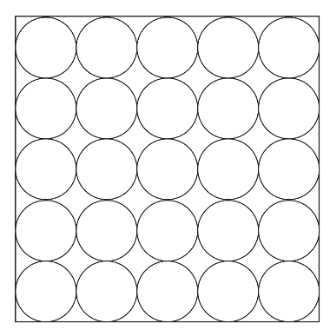 | 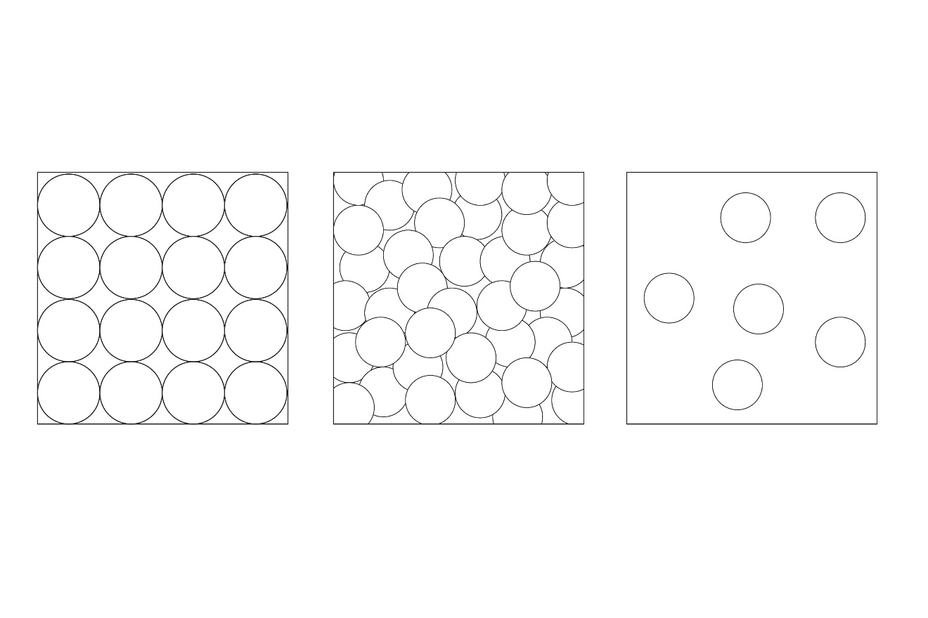
iron | mercury | helium

(d)
- The particles vibrate in fixed positions.
- The particles are able to move past each other.
- The particles move freely in all directions.

(e)
- The particles are arranged in a regular way and are in fixed positions.
- The particles are able to move past each other.
- The particles are arranged apart from each other and can move freely throughout a shape.


- Guidance note: This question develops learners’ understanding of how different physical, diagrammatic or animated versions of the particle model (symbolic understanding) can be used to explain physical properties of substances in terms of particles (sub-microscopic understanding) and the properties of different states of matter (macroscopic understanding.

Please note that these questions may be used to promote discussion. Learners may give a range of ideas rather than one definitive answer.
- B

Answers could include ideas such as:
- Marbles pouring out of the beaker show how the particles are able to move past each other.
- The 2D and 3D models do not show movement of the particles.
- The animation shows particle movement but only one container (so it does not show how the particles would move if a liquid was poured).
- C

Answers could include ideas such as:
- The 3D model shows a fixed 3D shape.
- The 2D model and the animation are flat and so do not show a fixed 3D shape.
- The marbles in the beaker do not show a regular arrangement of particles and the marbles are not fixed to each other.
- D

Answers could include ideas such as:
- The animation shows the movement of particles.
- The animation shows how particles spread out to fill a space.
- The 2D diagram and the fixed 3D model do not show movement of the particles.
- The marbles cannot move in all three dimensions.
- Guidance note: This question develops learners’ understanding of why a gas can be compressed but not a liquid (macroscopic understanding) in terms of the arrangement of particles in each state (sub-microscopic understanding). This also involves developing understanding that the gap between circles in a particle diagram represents empty space (symbolic understanding).
- The particles are already touching each other. They cannot move closer to each other.

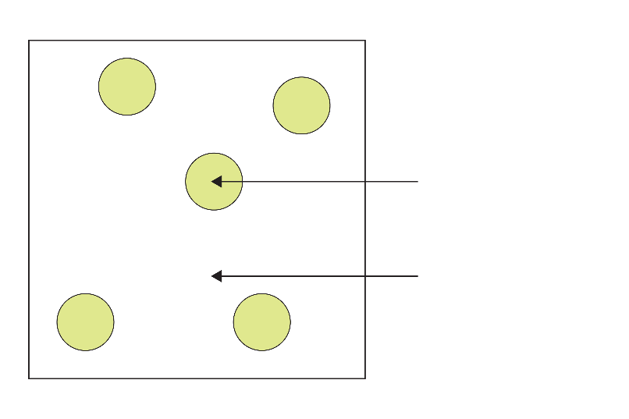
neon particle
nothing / empty space / vacuum
- There is nothing between the particles so the particles can move closer to each other.

Acknowledgements

Question 2 shows a screenshot from an online animation created by PhET at the University of Colorado. You can access the States of Matter simulation online at: https://phet.colorado.edu/sims/html/states-of-matter-basics/latest/states-of-matter-basics_en.html

Image sources for student sheet

Question 1: iron nail © Shutterstock / Panupong786; helium filled balloon © Shutterstock / Soho A Studio; mercury © Shutterstock / MarcelClemens

Question 2: A © Royal Society of Chemistry; B © Shutterstock / RousePhotography; C © Shutterstock / 3d-sparrow; D © PhET / University of Colorado

Question 3 © Royal Society of Chemistry

