The change in mass when magnesium burns

Learning objectives
- Safely investigate burning magnesium to produce magnesium oxide.
- Correctly record the change in mass.
- Explain why the mass changes.
- Use data to calculate the relative formula mass.

Introduction

In this experiment, you will record the mass of magnesium and heat it in a crucible, calculating the change in mass from before it is heated to after. You will then calculate the formula of magnesium oxide.

Equipment

Apparatus
- Safety glasses
- Access to a balance (2 decimal places)

Per group:
- Crucible with lid
- Tongs
- Pipe clay triangle
- Bunsen burner
- Tripod
- Heat resistant mat
- Emery paper

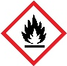
Chemicals
- Magnesium ribbon, 5−10 cm, DANGER: flammable solid

Health and safety
- Wear eye protection throughout
- NEVER look directly at magnesium when it is burning

Diagram

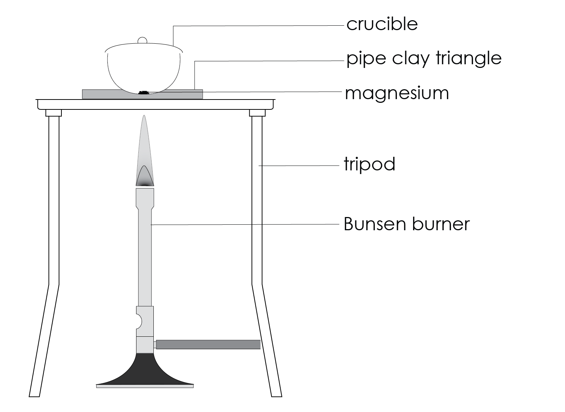
heat resistant mat

Method
- Take a piece of magnesium 5−10 cm long. If it looks tarnished or black, then clean it using the emery paper. Twist it into a loose coil.
- Record the mass of the crucible with the lid (mass 1) and then the magnesium inside the crucible with the lid (mass 2).
- Set up the Bunsen burner on the heat resistant mat with the tripod. Place the pipe clay triangle over the tripod to make a six-pointed star shape, making sure that it is secure. Place the crucible containing the magnesium in the pipe clay triangle and put the lid on.
- Light the Bunsen burner and begin to heat the crucible. It is best to start with a gentle blue flame, then increase to a roaring flame (with the air hole fully open) to get the reaction to go.
- Once the crucible is hot, gently lift the lid with tongs a little to allow some oxygen to get in. You may see the magnesium begin to flare up. If the lid is off for too long, then the magnesium oxide product will begin to escape. Don’t let this happen.
- Keep heating and lifting the lid until you see no further reaction.
- Turn off the Bunsen burner and allow the apparatus to cool.
- Re-record the mass of the crucible with lid containing the product (mass 3).
- Heat the crucible again for a couple of minutes and once again allow to cool. Repeat this step until the mass readings are consistent. This is known as heating to constant mass.

Results table
Mass 1 (g)  crucible + lid | Mass 2 (g)  crucible + magnesium + lid before heating | Mass 3 (g)  crucible + product + lid after heating

Questions
- Using your data above, state what happened to the mass during this reaction.

__________________________________________________________________________________

- In this experiment, magnesium ($Mg$) was heated with oxygen ($O_{2}$) in the air to form magnesium oxide ($MgO$).
- Write a word equation for the reaction (use the information above).

__________________________________________________________________________________
- Complete the balanced symbol equation for this reaction:

$2 ____ + O_{2} → 2 _______$
- Identify the reactants in this reaction (found after the arrow in the equation).

__________________________________________________________________________________

- Identify the product in this reaction (found after the arrow in the equation).

__________________________________________________________________________________

- Describe what happened to the mass during this reaction. Delete as appropriate.

The mass during the reaction increased/decreased. This is because the oxygen/carbon dioxide from the air is a liquid/gas and also has mass. Therefore, these atoms chemically/physically bond to the magnesium atoms, thus increasing/decreasing the mass.

- Explain why the lid must not be fully removed from the crucible during this reaction. Use the key words below.

escape fine low mass oxide

Magnesium ____________ powder is very ____________ and could ____________ from the crucible into the air. This would give a ____________ reading for the product that is too ____________.

Extension − finding the formula of magnesium oxide

Method one

To find the formula of magnesium oxide, you will need to calculate the ratio between the number of moles of magnesium and the number of moles of oxygen in the compound.

The equation to calculate the number of moles is:

$$Number of moles of element= \frac{mass of element}{A_{r}of element}$$

The relative atomic mass (A_{r}) of magnesium is 24 and the A_{r} of oxygen is 16.

To calculate the ratio, you need to divide the larger Number of moles of element by the smaller number.

If the ratio is close to 1:1, the formula of magnesium oxide is $MgO$.

If the ratio is close to 1:2, the formula of magnesium oxide is $MgO_{2}$.

If the ratio is close to 2:1, the formula of magnesium oxide is ${Mg}_{2}O$.

Example calculation

Mass of magnesium $= 2.39 g$

Mass of magnesium oxide $= 3.78 g$

Mass of oxygen$= 1.39 g$

A_{r} of $Mg = 24$

A_{r} of $O = 16$

Number of moles $Mg = \frac{2.39}{24} = 0.0995$

Number of moles of $O = \frac{1.39}{16} = 0.0868$

Divide by the number of moles of magnesium by the number of moles of oxygen to give the ratio:

$$Ratio of Mg:O=1:\frac{Number of moles of Mg}{Number of moles of O}= 1:\frac{0.0995}{0.0868}=1:1.15$$

Now use your data:
Mass of magnesium
(mass 2 – mass 1)
Mass of magnesium oxide
(mass 3 – mass 1)
Mass of oxygen
(mass 3 – mass 2)

$Number of moles of Mg= \frac{mass of Mg}{A_{r} of Mg}= \frac{ }{24}$ = ________

$Number of moles of O= \frac{mass of O}{A_{r} of O}= \frac{ }{16}$ = ________

Divide the number of moles of Mg by the number of moles of O to give the ratio:

$$Ratio = \frac{Number of moles of Mg}{Number of moles of O}= \frac{ }{ }= ___________$$

Tick the box which represents the closest ratio that you have calculated from your data:
 | the ratio is closest to 1:1 | $$→$$ | the formula of magnesium oxide is $MgO$.
 | the ratio is closest to 1:2 | $$→$$ | the formula of magnesium oxide is $MgO_{2}$.
 | the ratio is closest to 2:1 | $$→$$ | the formula of magnesium oxide is ${Mg}_{2}O$.

Method two

Collect all the mass of magnesium and mass of oxygen data for your class. Plot all the class data onto the graph below:
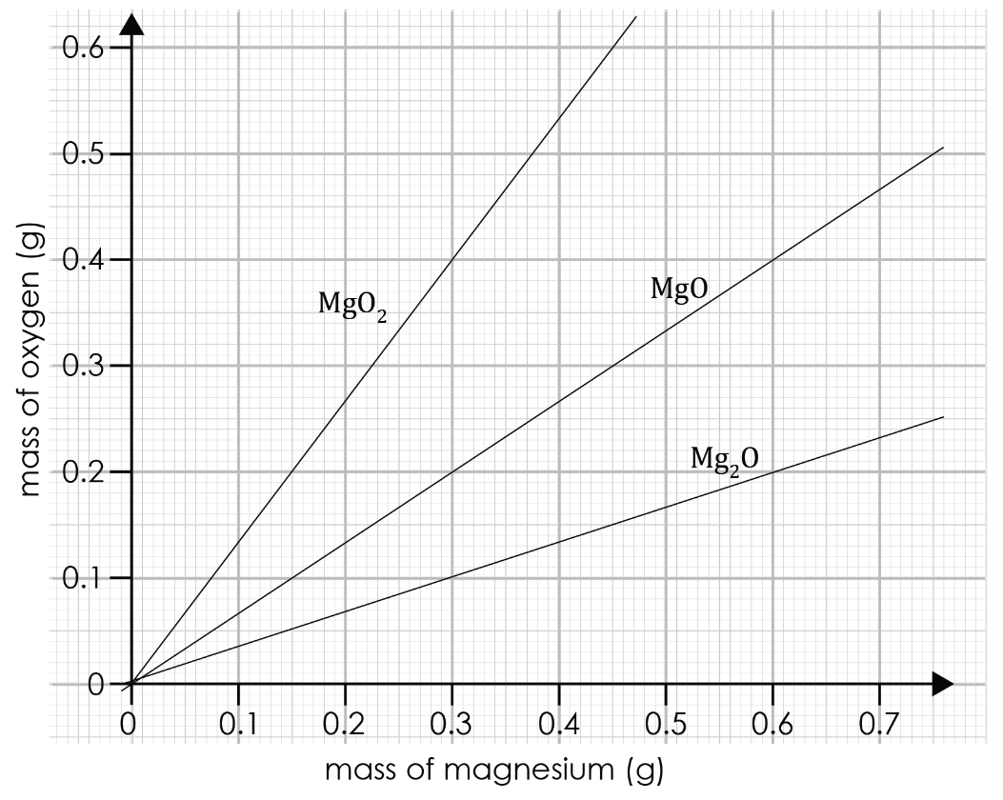

Draw a straight line of best fit.

Compare this to the pre-drawn lines on the graph.

What is the formula of magnesium oxide?

_____________________________________________________

