Hydrogen and oxygen reaction equation: Johnstone’s triangle

Learning objectives
- Recognise the chemical formulas used in the equation.
- Interpret the state symbols used in the equation.
- Describe what is shown by the balanced chemical equation.

Introduction

The reaction between hydrogen and oxygen can be represented as a balanced chemical equation. This shows how the number of hydrogen and oxygen molecules that react and the molecules of water produced are related. State symbols show the state of each reactant and product.

Johnstone’s triangle

In chemistry we make sense of the things that we can see by representing what we can’t see using formulas, equations, diagrams and models.

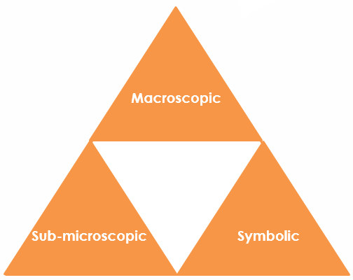

Johnstone’s triangle is a way of thinking about these different concepts as different corners of a triangle:
- Macroscopic – what we can see. Think about the properties we can observe, measure and record.
- Sub-microscopic – smaller than we can see. Think about the particle or atomic level.
- Symbolic – representations. Think about how we represent chemical ideas, including symbols and diagrams.

Being able to connect and move between these three different levels is important for scientific understanding.
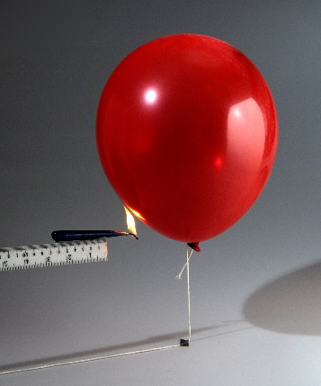
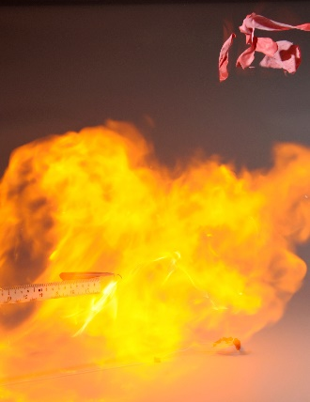

Macroscopic - what we can see

If a balloon of hydrogen is lit by a burning splint it will explode with a loud bang.

Name the gas in the air that reacts with the hydrogen.

_______________________________________________________

Suggest why no liquid water is observed after the reaction.

_______________________________________________________________________________

_______________________________________________________________________________

_______________________________________________________________________________

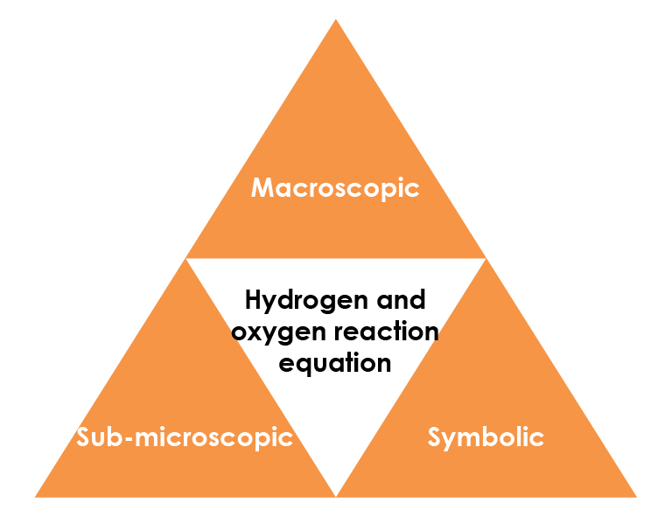

Sub-microscopic - smaller than we can see

Add numbers to the sentence to describe what is shown by the balanced chemical equation.

Every ________ molecules of hydrogen react with ________ molecule of oxygen to produce ________ molecules of water.

Explain why the following equation cannot be correct.

$H_{2}$(g) + $O_{2}$(g) → $H_{2}O$(g)

__________________________________________________

__________________________________________________

__________________________________________________

__________________________________________________

Symbolic - representations

Give the chemical formula of each reactant and product in the equation:

2$H_{2}$(g) + $O_{2}$(g) → 2$H_{2}O$(g)

hydrogen: _____________________

oxygen: ________________________

water: _________________________

Give the state of both reactants and the product.

_________________________________

© Science Photo Library

