Iron and sulfur reaction: Johnstone’s triangle

Learning objectives
- Recognise that the properties of a product are different to the reactants.
- Identify the diagram that represents the arrangement of atoms in each reactant and product.
- Write a word and symbol equation for the reaction.

Introduction

The elements iron and sulfur react to form the compound iron sulfide. Iron and sulfur are the reactants. Iron sulfide is the product which has different properties to the reactants.

Johnstone’s triangle

In chemistry we make sense of the things that we can see by representing what we can’t see using formulas, equations, diagrams and models.

Johnstone’s triangle is a way of thinking about these different concepts as different corners of a triangle:
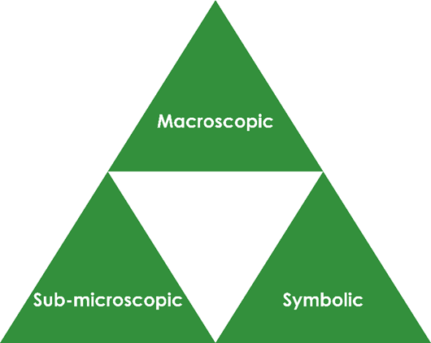

- Macroscopic – what we can see. Think about the properties we can observe, measure and record.
- Sub-microscopic – smaller than we can see. Think about the particle or atomic level.
- Symbolic – representations. Think about how we represent chemical ideas, including symbols and diagrams.

Being able to connect and move between these three different levels is important for scientific understanding.

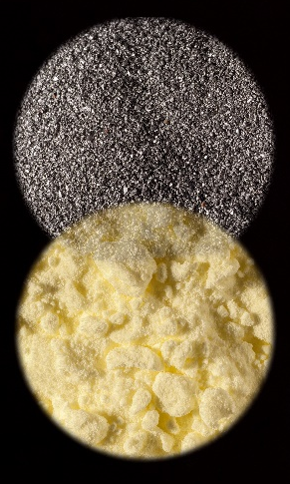


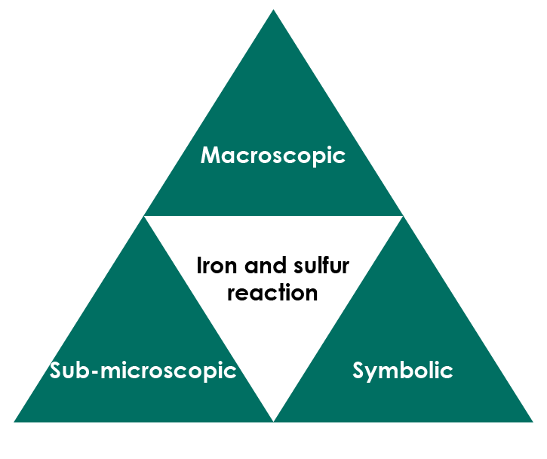

Symbolic – representations

Complete the word equation for the reaction to show the two reactants and the product.

___________ + ____________ → ____________________

Draw lines to connect the element symbol and chemical formula with the correct reactant or product.

iron FeS

sulfur Fe

iron sulfide S

Suggest why the symbol for iron is not I.

_____________________________________________________________

______________________________________________________________

Add the element symbols and a chemical formula to complete the chemical symbol equation for the reaction.
_______________ + _______________ → ______________

Sub-microscopic – smaller than we can see

The arrangement of atoms in a reactant or product can be shown using a diagram.

This key shows the colour used to represent each type of atom.

iron atom sulfur atom

Name which reactant and product (iron, sulfur or iron sulfide) is represented by each diagram.

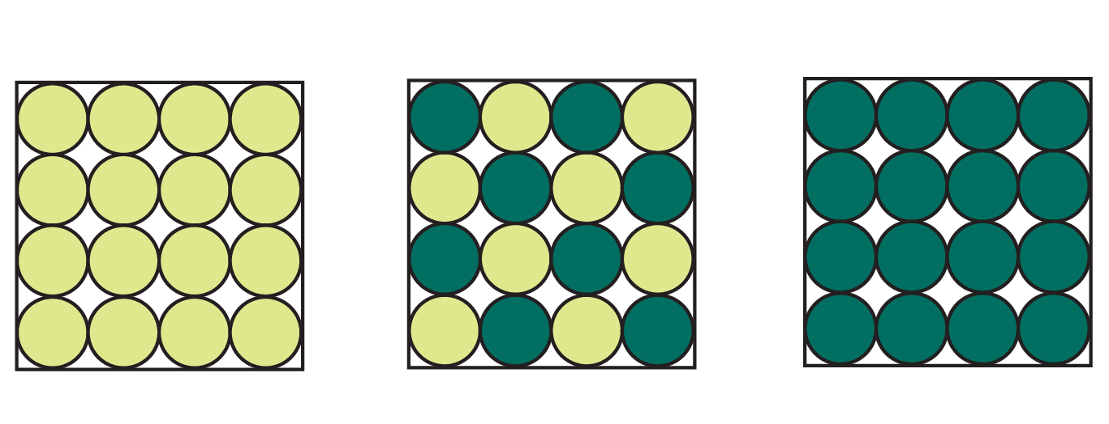

______________ _____________ ______________

© Martyn F Chillmaid / Science Photo Library

Macroscopic – what we can see

Sulfur is a yellow non-metal. Iron is a shiny grey, magnetic metal.

Name the product of the reaction between iron and sulfur.

_________________________________________________________________

Explain why the product is not magnetic, even though one of the reactants is. _________________________________________________________________

_________________________________________________________________

